

UNDERGRADUATE PROJECT PROGESS REPORT

|  |  |
| --- | --- |
| **Project Title:** | **Ensemble learning for the classification of Alzheimer disease** |
| **Surname:** | **Liu** |
| **First Name:** | **Yue** |
| **Student Number:** | **201918020206** |
| **Supervisor Name:** | **Grace U. Nneji** |
| **Module Code:** | **CHC 6096** |
| **Module Name:** | **Project** |
| **Date Submitted:** | **1/10/2023** |

**Table of Contents**

1 Introduction 3

1.1 Background 3

1.2 Aim 3

1.3 Objectives 3

1.4 Project Overview 4

1.4.1 Scope 4

1.4.2 Audience 4

2 Background Review 4

3 Project Technical Progress 6

3.1 Methodology 6

3.1.1 Approach 6

3.1.2 Technology 10

3.2 Testing and Evaluation 10

3.3 Design and Implementation 11

4 Project Management 11

4.1 Activities 11

4.2 Schedule 12

4.3 Project Version Management 13

4.4 Project Data Management 13

4.5 Project Deliverables 13

5 Professional Issues and Risk: 13

5.1 Risk Analysis 13

5.2 Professional Issues 14

6 References 14

# Introduction

## Background

Alzheimer's disease (AD) involves the part of the brain that controls thought, memory and language, and is a progressive neurodegenerative disease with an insidious onset, the most common type of dementia with no known cause [1]. The majority of people with Alzheimer's disease are elderly. With the global ageing process, the number of people with Alzheimer's disease is likely to grow by over 100 million worldwide. At the same time, the cost of treatment will increase significantly and there is no cure for Alzheimer's disease, which could bring a certain degree of economy pressure to the world. The diagnosis of Alzheimer's disease is therefore one of the breakthroughs in solving this problem using Magnetic resonance imaging (MRI) [2].

## Aim

The project aims to take advantage of ensemble model for the efficient classification of Alzheimer disease, so as to take early measures to reduce mortality and reduce cost of medical resources.

## Objectives

1. Get to know what ensemble learning is.
2. Have a brief understanding about how to realize the medical image classification with the use of ensemble learning.
3. Explain more about the classification of Alzheimer disease with the use of ensemble learning.
4. Realize and evaluate about the model using different performance metrics such as accuracy, sensitivity, specificity, recall, precision, F1-score, ROC curve.
5. Model tweaking and fitting.
6. Final presentation of this project to the targeted audience.

## Project Overview

### Scope

It is well known that Convolutional Neural Networks (CNN)'s fast feature extraction capability makes its pattern recognition in image data analysis very effective. In addition, it has high accuracy in image classification, such as medical imaging [3]. But CNN model application could face one or more challenges which could be overfitting, be underfitting, the gradient disappears, etc. Thus, the purpose of this project is to take the merit of single channel CNN models and concatenate them for a robust performance which is refer to as Ensemble learning for the classification of Alzheimer disease.

The significant of this study include:

* To help patients find health problems in time
* For researchers to carry out effective study for the diagnosis and treatment of the disease
* For medical purpose
* To reduce mortality rate
* To help reduce medical practitioner time and resources.

### Audience

* Patients with Alzheimer's disease.
* Physicians.
* Hospital.
* Medical magnetic resonance imaging manufacturer

# Background Review

Deep neural network has been utilized for analyzing and predicting medical images for physician and radiologists during diagnostics decision.

Fulton et al employed a ResNet model in diagnosing three classes and achieved 98.99% [4].

Maqsood et al proposed a transfer learning and fine-tuned AlexNet and achieved an accuracy of 92.85% for multi-class of the OASIS dataset [5].

Alanazi et al compared the hybrid algorithm between machine learning and deep learning in deep learning, and found that the accuracy, sensitivity, specificity and AUC values of the AlexNet+SVM model were 94.8%, 93%, 97.75% and 99.7% respectively, which was better [6].

In Lu et al’s research, when the number of iterations reaches 200, the accuracy of VGG 16 converges to 93% on the training set, and the accuracy of MobileNet converges to 98%, proving that the MobileNet network model is superior to the VGG 16 network model in terms of AD MRI image classification [7].

Plocharski et al developed an algorithm to calculate the inner surface of the groove for feature extraction, and based on this, proposed a model to distinguish AD patients from ordinary people, the accuracy, sensitivity and specificity of the model were 87.9%, 90% and 86.7% [8].

Elakkiya et al used the DEMNET (Dementia Network) model based on CNN to detect the four different stages of AD, and used the SMOTE method for data enhancement. The results of the model reached 95.23% of the test accuracy [9].

Rehman et al proposed hybrid classical quantum network for automatic detection of AD and ResnNet34 for feature extraction, achieving the highest test accuracy of 97.2% [10].

Table 1: Summarize the related work for Alzheimer disease classification.

|  |  |  |
| --- | --- | --- |
| Authors | Proposed Model/Technique | Performance Metrics |
| Fulton et al. [4] | ResNet50 model | Accuracy = 98.99% |
| Maqsood et al [5] | Fine-tuned AlexNet | Accuracy = 92.85% |
| Alanazi et al [6] | AlexNet+SVM hybrid models  ResNet-50+SVM hybrid models | Accuracy = 94.8%  Accuracy = 93.3% |
| Lu et al [7] | MobileNet | Accuracy = 98% |
| Plocharski et al [8] | Model for extracting medical features using a medical superficial sulcal pattern | Accuracy = 87.9%  Sensitivity = 90%  Specificity = 86.7% |
| Elakkiya et al [9] | DEMentia NETwork | Accuracy = 95.23% |
| Rehman et al [10] | The proposed hybrid classical quantum network /ResnNet34 | Accuracy = 97.2% |

# Project Technical Progress

## Methodology

### Approach

* Models: ResNet + AlexNet + MobileNet

The residual network(ResNet) is constructed from Residual Building Blocks, it does not increase the complexity of the network while increasing the depth of the network, and the effect is far better than other networks such as VGG and Google Net. With the increase of the number of floors, this advantage becomes more and more obvious. The quick connection of ResNet makes the network easier to optimize. The internal residual block uses a skip connection, which alleviates the problem of gradient disappearance caused by increasing depth in the deep neural network. This is a layer of convolution, a residual block containing convolution and pooling, then a layer of convolution is added, a layer of tiling is added, a layer of full joins is added, then a layer of dropout, and then the output layer.

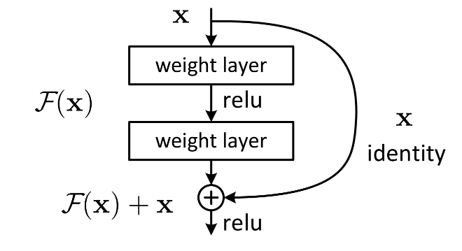

Figure 1: ResNet Architecture

AlexNet has an eight layer structure. The first five layers are convolutional neural networks, and the sixth to eighth layers are traditional neural networks. It uses the ReLU activation function to prevent the gradient from disappearing and the Dropout to prevent over fitting . In this network structure, the first layer is a convolutional layer, followed by four convolutional layer, a Flatten layer, two consecutive Dense fully-connected layers, each with a Dropout layer, and the final layer is the output layer. The whole network can be seen as the input layer is operated by convolutional layers, followed by a series of fully connected layers, and finally the output layer is used to obtain the prediction result.

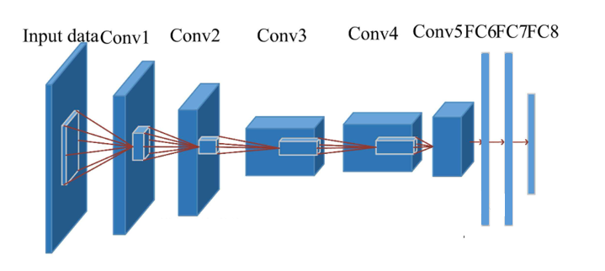

**Figure 2: AlexNet Architecture**

The MobileNet structure uses depthwith separable convolution to replace the standard convolution operation, and calls these two structures repeatedly to reduce the amount of model parameters and increase the amount of model calculation. Each layer is followed by a batchnorm and a ReLU nonlinear layer. Finally, the Flatten layer and the full connection layer are used to classify the images. Point convolution and deep convolution structure are the core of MobileNet, which makes MobileNet more efficient and more suitable for mobile devices. Point convolution is mainly responsible for integrating the information in the feature map, while depth convolution is responsible for extracting features.

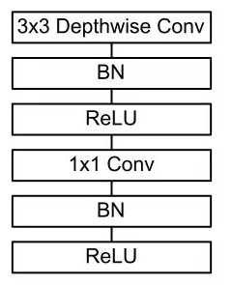

**Figure 3: MobileNet Architecture**

For a given training sample S, M training samples were drawn from the training sample S in each round using Booststraping, and n rounds were conducted to obtain a total of n sets of samples. After obtaining the sample sets, one prediction model is obtained each time using one sample set, for n sample sets, a total of n prediction models can be obtained. The classification results are then obtained by applying voting to the previously obtained n models.

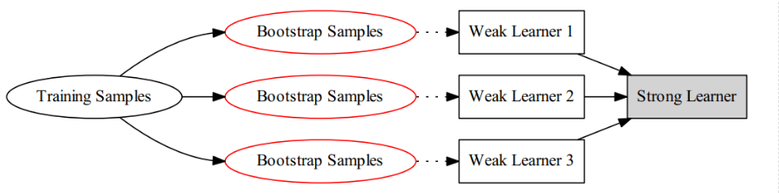

**Figure 4: Structure of the model**

* Algorithm

Bagging: To obtain an integration with strong generalisation performance, the ensemble learning in the integration should be as independent of each other as possible, or try to make the base learners as undifferentiated as possible. Given a training dataset, one possible approach is to sample the training samples to produce a thousand different subsets, and then train a base learner from each subset of the data. This is expected to result in a large variation in the base learners due to the different training data, however, in order to obtain better integration, it is also desirable that individual learning is not too poor, and if each subset sampled is completely different, then each learner uses only a small fraction of the training data, not even enough to learn effectively, neither of which is clearly guaranteed to produce a better base learner. Therefore, to solve this problem, consider using sampled subsets that are overlapping with each other.

* Full connection

The convolution part is mainly the operation between convolution kernel and data, and the multiplication and addition of matrix.

Activation function part, relu activation function and softmax activation function.

The pooling part, which can be said to be downsampling, effectively reduces network parameters, mainly including maximum pooling and average pooling. The basis is to calculate the maximum and average.

The fully connected part is the product of a matrix and a vector. The output is a vector. For example, the matrix of 1 * M is multiplied by the matrix of M * N to obtain a 1 * N matrix.

* Back propagation

It is necessary to derive the gradient, calculate the gradient value of each training update parameter, and then update the weight and offset, that is, the addition and subtraction of matrix vectors

* Optimization strategy.

Some Adam optimizers are used for backpropagation, or the size of batch training is adjusted to avoid local optimal solution

* Dataset

There are 33984 cross-sectional MRI images of the brain with Alzheimer's disease in the data set of this project, including 8960 MRI images of mild dementia, 6464 MRI images of moderate dementia, 9600 MRI images of non-dementia, 8960 MRI images of very mild dementia, training set, verification set, and test set, with a distribution ratio of 6:2:2.

* Data processing technology

First, data reading is required. Since the pixels of each image are different, you need to use the cv library to reset all image sizes to a uniform size. Second, in order to make training more stable, you can normalize the image size to between 0 and 1, that is, divide all data by 255.

### Technology

Framework: Tensorflow

IDE: Vscode

Language: Python

CUDA, cuDNN, Tensorflow-gpu

Central processing Unit (CPU): Intel(R) Core (TM) i7-9750H CPU @ 2.60GHz 2.59 GHz

Graphic Processing Unit (GPU): NVIDIA GeForce GTX 1650

## Testing and Evaluation

First, the training data is divided into training set and validation set. The validation set is not fed into the training of the neural network, but only the training set is fed into the training of the neural network and the parameters are updated. The validation set is responsible for the learning ability of the network and outputs the training results of the training set and validation set to the terminal.Then, after the training, the test set is partially input to the neural network, and the network is not trained at this time, only the data is read and output, and the prediction is verified to be correct.

|  |  |  |
| --- | --- | --- |
|  | Positive | Negative |
| True | True Positive | True Negative |
| False | False Positive | False Negative |

$$Accuracy=\frac{TP + TN}{TP +FP +TN +FN}$$

## Design and Implementation

First, three commonly used models, ResNet, AlexNet, and MobleNet, are selected based on the needs of the project. The dataset is divided into 6:2:2 and the pictures are set to a uniform size after processing with the cv library because the data needs to be read. With ResNet, the epoch in the code is set to 20, which means the total number of rounds is 20, batch_ The size setting of 32 means that the neural network will retrieve 32 data at one time for training. Each epoch during training tests the accuracy in the training set and the verification set, and saves the model. Then write the calculation loss, reverse propagation, and optimizer, where the optimizer optimizes reverse propagation.

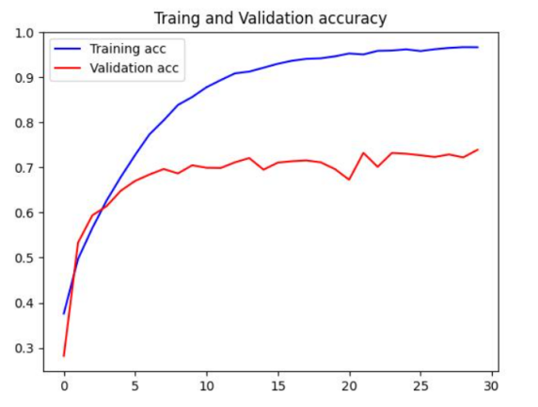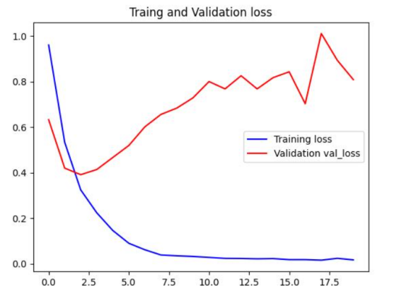

**Figure 5: ResNet ACC Figure 6: ResNet Loss**

It can be seen from the figure that the model may be over-fitted and still needs to be improved. The AlexNet model and MobileNet model still have problems that need to be improved. The integration algorithm is currently selected as the bagging algorithm.

# Project Management

## Activities

|  |  |  |  |
| --- | --- | --- | --- |
| Activities | Completion time | Completion status | Current progress |
| Find dataset | 1 week | 100% |  |
| Literature Review | 6 weeks | 80% | Risks and problems encountered in implementation still require more access to information to avoid or resolve. |
| Requirements Analysis | 6 weeks | 100% |  |
| Project Proposal | 2 weeks | 100% |  |
| System Design | 4 weeks | 90% | In the process of implementation, it still needs to be adjusted and improved according to the actual situation. |
| Implementation | 7 weeks | 60% | The model establishment has been completed, the training has been realized, and the implementation of bagging algorithm has been progressed. |
| Progress Report | 2 weeks | 70% | The details need to be worked out. |
| Testing | 3 weeks | 20% | Planning for testing is complete. |
| Evaluation | 1 weeks | 20% | Planning for evaluation is complete. |
| Final Report | 7 weeks | 10% |  |
| Final Presentation | 1 weeks | 10% |  |

## Schedule

Completed Uncompleted

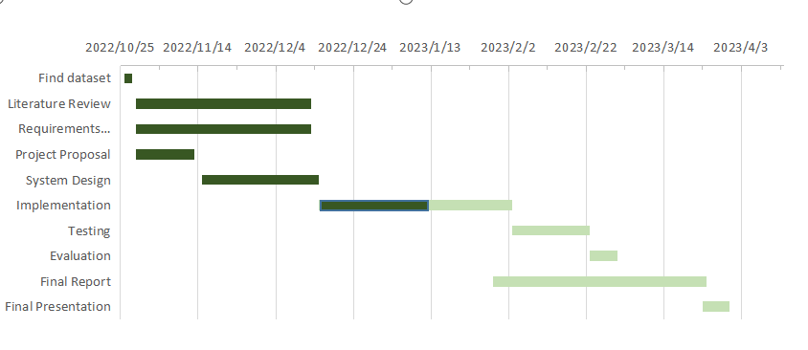

**Figure 7: Gantt Diagram**

## Project Version Management

In the GitHub account, create the repository and complete the repository information Settings, complete the git download, and commit the code to the staging area, then commit to the local git repository, and then commit it to github.

## Project Data Management

Use cloud folders to store data

* weekly project logs: progress, draft, next steps, supervisor comments, requirements or user stories.
* Project materials: sprint plans/reviews, testing documentation, literature etc.
* Reports: proposal, interim, final.

## Project Deliverables

* Weekly report
* The project proposal
* Image classification and diagnosis system of Alzheimer's disease (Codes)
* The progress report
* Project presentation (PPT)
* Final report - 10000 words

# Professional Issues and Risk:

## Risk Analysis

|  |  |  |  |  |  |  |  |  |
| --- | --- | --- | --- | --- | --- | --- | --- | --- |
| **Risk ID** | **Potential Risk** | **Cause ID** | **Potential Causes** | **Severity** | **Likelihood** | **Risk** | **Mitigation ID** | **Mitigation** |
| R1.1 | Late in deadline | C1.1.1 | Poor time management | 3 | 3 | 9 | M1.1.1 | Do not make too detailed daily arrangements, but take the number of days as the standard, and more strictly abide by the schedule. |
| C1.1.2 | Illness | 1 | 2 | 2 | M1.1.2 | Do what I can currently do, and plan how to make up for the delayed progress |
| C1.1.3 | Technology selection | 2 | 1 | 2 | M1.1.3 | Consult more information to determine the advantages and disadvantages of technology and the needs of the project to determine the appropriate technology faster. |
| R1.2 | Operating speed | C.1.2.1 | Insufficient video memory | 1 | 3 | 3 | M1.2.1 |  |
| R1.3 | Algorithm selection | C1.3.1 | Defects of bagging algorithm | 1 | 5 | 5 | M1.3.1 | Selecting a Base Classifier with High Stability |
| R1.4 | Picture pixels | C1.4.1 | Picture pixels are 64*64 due to device limitations, which may result in lower accuracy. | 2 | 5 | 10 | M1.4.1 |  |
| R1.5 | Model selection | C1.5.1 | MobileNet is often used on moving objects | 1 | 3 | 3 | M1.5.1 |  |

## Professional Issues

There are no copyright or plagiarism issues with this project's work. The IDE and framework of its projects and datasets are downloaded from the network, and they are open source and publicly available for research purposes.

# References

1. An, N., Ding, H., Yang, J., Au, R., & Ang, T. F. A. (2020). Deep ensemble learning for Alzheimer's disease classification. Journal of Biomedical Informatics, 105, 103411. https://doi.org/10.1016/j.jbi.2020.103411
2. Bi, X., Liu, W., Liu, H., & Shang, Q. (2021). Artificial Intelligence-based MRI Images for Brain in Prediction of Alzheimer’s Disease. Journal of Healthcare Engineering, 2021, 1–7. https://doi.org/10.1155/2021/8198552
3. Wang, H., Shen, Y., Wang, S., Xiao, T., Deng, L., Wang, X., & Zhao, X. (2019). Ensemble of 3D densely connected convolutional network for diagnosis of mild cognitive impairment and Alzheimer’s disease. Neurocomputing, 333, 145–156. https://doi.org/10.1016/j.neucom.2018.12.018
4. Fulton, L., Dolezel, D., Harrop, J., Yan, Y., & Fulton, C. (2019). Classification of Alzheimer’s Disease with and without Imagery Using Gradient Boosted Machines and ResNet-50. Brain Sciences, 9(9), 212. https://doi.org/10.3390/brainsci9090212
5. Maqsood, M., Nazir, F., Khan, U., Aadil, F., Jamal, H., Mehmood, I., & Song, O. (2019). Transfer Learning Assisted Classification and Detection of Alzheimer’s Disease Stages Using 3D MRI Scans. Sensors, 19(11), 2645. https://doi.org/10.3390/s19112645
6. Mohammed, B. A., Senan, E. M., Rassem, T. H., Makbol, N. M., Alanazi, A. A., Al-Mekhlafi, Z. G., Almurayziq, T. S., & Ghaleb, F. A. (2021). Multi-Method Analysis of Medical Records and MRI Images for Early Diagnosis of Dementia and Alzheimer’s Disease Based on Deep Learning and Hybrid Methods. Electronics, 10(22), 2860. https://doi.org/10.3390/electronics10222860
7. Lu, X., Wu, H., & Zeng, Y. (2019). Classification of Alzheimer’s disease in MobileNet. Journal of Physics: Conference Series, 1345(4), 042012. https://doi.org/10.1088/1742-6596/1345/4/042012
8. Plocharski, M., & Østergaard, L. R. (2016). Extraction of sulcal medial surface and classification of Alzheimer’s disease using sulcal features. Computer Methods and Programs in Biomedicine, 133, 35–44. https://doi.org/10.1016/j.cmpb.2016.05.009
9. Murugan, S., Venkatesan, C., Sumithra, M. G., Gao, X.-Z., Elakkiya, B., Akila, M., & Manoharan, S. (2021). DEMNET: A Deep Learning Model for Early Diagnosis of Alzheimer Diseases and Dementia From MR Images. IEEE Access, 9, 90319–90329. https://doi.org/10.1109/ACCESS.2021.3090474
10. Shahwar, T., Zafar, J., Almogren, A., Zafar, H., Rehman, A. U., Shafiq, M., & Hamam, H. (2022). Automated Detection of Alzheimer’s via Hybrid Classical Quantum Neural Networks. Electronics, 11(5), 721. https://doi.org/10.3390/electronics11050721